Describe your day in school using the adverbs below.
carefully | quickly | bravely
neatly | safely | hungrily
happily | sleepily | cheerfully
playfully | quietly | slowly
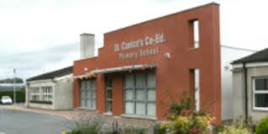
Adverbs

I walked _________________ to school.
I went to my line and I chatted __________ to my friends.
When I went into class I said “good morning” _____________ to Ms O’Connor.
I started my work _________.
I did my writing ___________
When I was not sure of the answer I still put up my hand _____________.
I couldn’t wait for breaktime and I ate my lunch ______________.
When I went out to yard my friends and I ___________ made up a new game.
That night I was so tired after school, I went to bed __________.

