Selfie Sounds  1 | More or Less at Dinnertime  2 | Name Practice  3
Left or Right Watch  4 | Days of the Week  5 | 3-D Shape Hunt  6
Word Cups  7 | Matching Socks  8 | Teddy Bear  Hide and Seek  9
2-D Shape Patterns  10 | Word Bang  11 | Coin Making  12
Character  Yes or NO Game  13 | Container Chat  14 | FINISHED
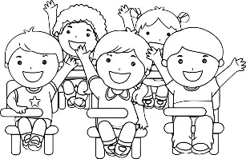
Senior Infants
Numeracy and Literacy Activities

Design your own page similar or just print this page. Colour in each activity as you finish them. You can do them in any order.
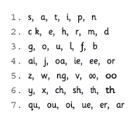
- Selfie Sounds
(Aim: To revise the Jolly Phonics sounds.)
With an adult go exploring around the house to see can you find something beginning with each letter of your Jolly Phonics sounds.
Once you find something, ask an adult to help you to take a selfie picture of you with the object that has the sound. Look back through all your pictures after to talk about the sounds.
This is your Jolly Phonics sound list in case you’ve forgotten!

- More or Less at Dinnertime
(Aim: To use and show understanding of the words more/less/most/least.)
When you are having dinner at home, ask can you help to put the dinner on the plates when it is ready.
Talk about who was more.
Talk about who has less.
Talk about who has the most.
Talk about who has the least.
Does anybody have the same?

- Name Practice!
(Aim: To practice writing first name and second name. Anything after this a bonus!)
Practice writing your first name and your second name in lot of different colours.
If you’ve mastered this you can try writing your address and an emergency phone number. This will always come in handy and it is something you will practice in 1st class!
You could make up your own form to fill in
Name:
Address:
Phone number:

- Left or Right Watch
(Aim: To identify right and left hands.)
We learned about left or right and we practiced making ‘L’ with our hands to see which hand made a proper ‘L’ shape (our left hand!).
Another way to remember your right and left is that people usually wear their watch on their left hand.
Make a watch from spare paper at home and use some Sellotape to stick it around your left hand.
Wear your watch for a day or two and see does it help you to remember your left hand.

- Days of the Week
(Aim: Learning the days of the week, this is a tricky objective and covered more in 1st class but it’s is good practice nonetheless.)
Practice saying the days of the week.
Sing them along to theme song of “The Adams Family”
https://www.youtube.com/watch?v=8GKmCQOy88Y
“There’s Sunday and there’s Monday.
There’s Tuesday and there’s Wednesday.
There’s Thursday and there’s Friday and then there’s Saturday!”
Can you say the days of the week by the end of the day?
6. 3-D Shape Hunt
(Aim: To revise the 3-D shapes.)
In Senior Infants we have learned lots about 3-D shapes.
The 3-D shapes we have learned are: cube, cuboid, sphere and cylinder.
Can you make a little chart like mine and see how many of these shapes you can find around your home?
Every time you spot one of these shapes draw a tick beside it.
At the end count how many you have of each shape.
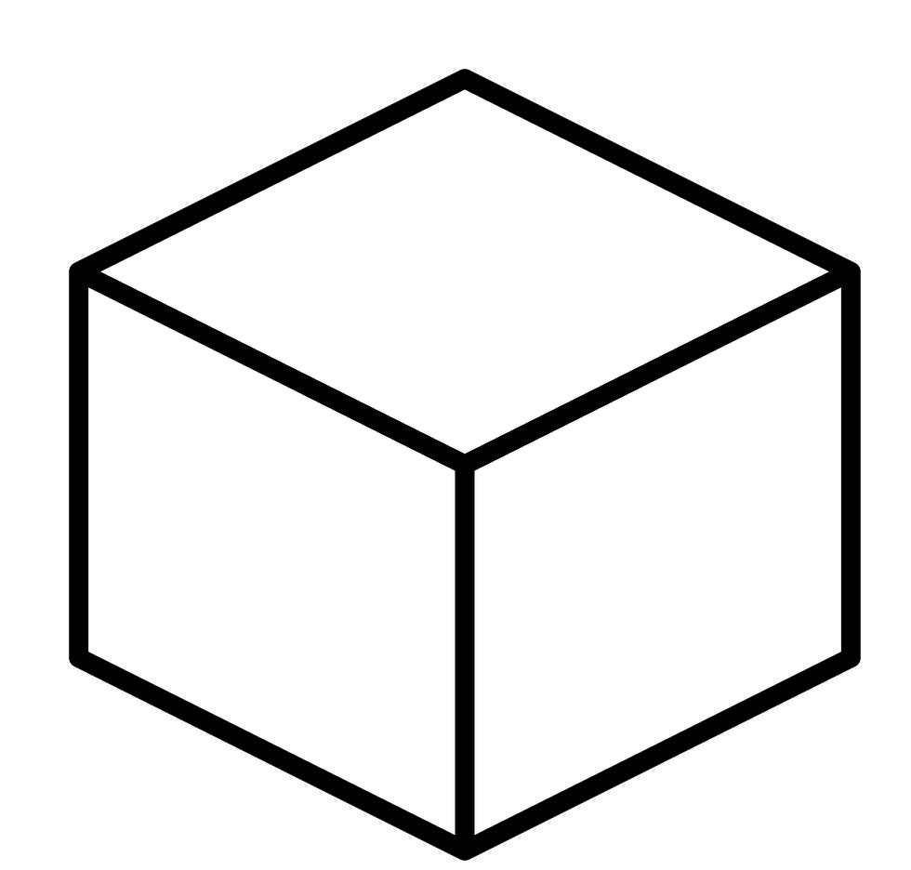 Cube | Sphere  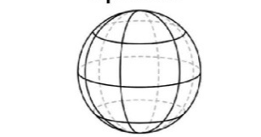
Cuboid | Cylinder

- Word Cups
(Aim: To play a game to practice tricky words or reader words.)
- Write some of your tricky words or words from your reader on little pieces of paper.
- Place all the pieces of paper on the table and cover them with cups so you can’t see the words.
- Close your eyes and ask an adult to place some counters or pieces of pasta (lego, anything you can count) under each cup.
- Lift-up each cup one at a time and read the word underneath.
- If you read the word correctly you can keep what is underneath. If it is too tricky try to sound it out, put the cup back down and try another cup.

- Matching Socks
(Aim: To practice making pairs. Also works on colour and shape and matching these together.)
- Ask an adult at home would they like some help to pair the socks together after the washing has been done.
- How many pairs of socks can you make?
- Are there any odd socks?

- Teddy Bear Hide and Seek
(Aim: To practice using the words first/second/third/next/last/between. Anything else is a bonus!)
- Find 5 of your favourite teddy bears or toys and put them in a line.
- Which Teddy Bear is first?
- Which Teddy Bear is second?
- Which Teddy Bear is third? (try fourth and fifth if 1st-3rd isn’t too tricky)
- Which Teddy Bear is last?
- Which Teddy Bear is between the first and the last teddy?

- Ask someone at home to hide the teddy bears or you hide them for someone else.
- Play Hide and Seek and find all the teddy bears.
- Talk about which teddy you found first/second/third/fourth/fifth/last/next/after/between.

- 2-D Shape Patterns
(Aim: To revise to 2-D shapes and to practice making patterns. Also good for building short-term memory skills.)
- The shapes we have learned so far in Senior Infants are:
circle, square, rectangle and triangle.
- Draw lots of these shapes and colour them in.
- Cut them out and make patterns with the shapes.
- Show someone at home your pattern, hide the pattern and see if they can make the pattern again from their memory.
(You could use the cardboard from leftover Easter egg boxes)

- Word Bang
(Aim: To play a game to practice reading tricky words or words from your reader.)
- Write some of your tricky words or words from your reader on spare pieces of paper.
- Spread the pieces of paper out on the floor and turn them upside down so you can’t see the words.
- Ask an adult or somebody at home to stick a post-it saying BANG on one or two of the words.
- Pick up one word at a time and if you can read it you keep it.
- If the word is too tricky try to sound it out and place it back down on the floor to try again.
- If you pick up the word with BANG you have to place all your words back down on the floor.
- If you want to play with someone else, the person with the most words at the end is the winner.
- You can make the game more interesting by adding post its like “take another turn” where you can take two turns in a row!

- Coins
(Aim: To practice exchanging coins and understanding that two 5c coins equals one 10c and so on. This can be very tricky for children to understand. Just being familiar with what the coins look like would be a great start.)
- Ask somebody at home to show you a 1c, 2c, 5c, 10c and 20c coin.
- Cut out lots of circles and make your own coins by copying the ones you have been shown at home.
- If someone at home can help you to swap the money you have made.
- For example: Ten 1cents is the same as one 10cent.
- You can watch euro being made in a Mint (where money is made)
https://www.youtube.com/watch?v=rFDsSMDeV3w

- Character Questions Yes or No Game
(Aim: To use the question words: who/what/when/where/why. Also to understand and answer questions.)
- Think of a person in your head and take a spare piece of paper and get ready to draw them.
- Make sure to:
Draw eyes and colour them in.
- Draw hair and colour it in.
- Draw their clothes and colour them in.
- You could draw glasses or things in their hair or draw some jewellery.
- When you have finished your drawing ask somebody at home to ask you questions about your drawing.
- You can only answer YES or NO.
For example:
- Is it a boy?
- Is it a girl?
- Do they have brown hair?
- Do they have green eyes
- What colour hair do they have?
- Are they wearing a jumper?
- Is the jumper red?
- Your partner at home needs to draw their picture to match yours just by listening to your answers.
- At the end compare your picture to your partner’s picture.
- Swap over and take it in turns to ask the questions and draw the picture.

- Containers Chat (Capacity)
(Aim: To use the words and phrases: full/empty/more/less/nearly full/holds more/holds less/nearly empty.)
- Collect empty bottles or containers around the house.
- Fill them up with water and discuss how much water each container holds.
(You could use some food colouring to change the colour of the water to make it more interesting if you had it handy at home.)
- Which container is full?
- Which container is empty?
- Which container holds more than the first container?
- Which container holds less than the last container?
- Which container is nearly empty?
- Which container is nearly full?

