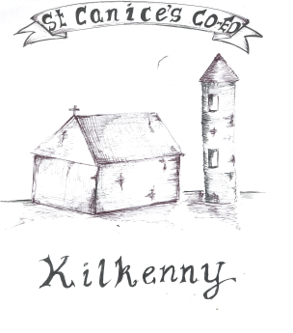
St Canice’s Co-Ed National School
Granges Road, Kilkenny.
Roll Number 19626A

Parental COMPLAINTS PROCEDURE/POLICY

Introduction
The Board of Management of ST.CANICE’S CO-ED. N.S., KILKENNY has adopted the INTO and Catholic Primary School Management Association’s (CPSMA) Complaints Procedure which provides a mechanism for dealing fairly with parental complaints against a teacher.

Rationale
The need for this policy arises from Section 28 of the Education Act 1998 which prescribes procedures for processing complaints by parents for all schools governed by the Act. The procedures outlined in this policy are intended to facilitate resolution of a complaint as speedily as possible and at the simplest level.

Relationship to School Ethos
ST.CANICE’S CO-ED. N.S., KILKENNY promotes positive home – school contacts and endeavours to enhance the self-esteem of everyone within the school community. Close cooperation between school and home is an integral part of our approach in ST.CANICE’S CO-ED. N.S. This policy contributes towards this goal.

Aims/Objectives
• To foster fruitful and trusting relationships between school and parents.
• To afford parents an opportunity to express opinions/grievances through the framework of a defined procedure.
• To minimize the opportunity for conflict, misunderstanding or mistrust.
• To afford parents an opportunity to liaise with the class teacher in a constructive and non-conflicting manner.
In-School Procedures
The INTO and Catholic Primary School Management Association reached agreement in 1993 on a procedure for dealing with complaints by parents against teachers. The purpose of this procedure is to facilitate the resolution of difficulties where they may arise in an agreed and fair manner. The agreement lays out in five stages the process to be followed in progressing a complaint and the specific timescale to be followed at each stage. Please note this is a non-statutory procedure.
Only those complaints about teachers which are written and signed by parents/guardians of pupils may be investigated formally by the board of management, except where those complaints are deemed by the board to be:
- on matters of professional competence and which are to be referred to the Department of Education and Skills;
- frivolous or vexatious complaints and complaints which do not impinge on the work of a teacher in a school; or
- complaints in which either party has recourse to law or to another existing procedure.

Unwritten complaints, not in the above categories, may be processed informally as set out in Stage 1 of this procedure.
Stage 1
- A parent/guardian who wishes to make a complaint should, unless there are local arrangements to the contrary, approach the class teacher with a view to resolving the complaint.
- Where the parent/guardian is unable to resolve the complaint with the class teacher s/he should approach the principal with a view to resolving it.
- If the complaint is still unresolved the parent/guardian should raise the matter with the chairperson of the board of management with a view to resolving it.

Stage 2
- If the complaint is still unresolved and the parent/guardian wishes to pursue the matter further s/he should lodge the complaint in writing with the chairperson of the board of management.
- The chairperson should bring the precise nature of the written complaint to the notice of the teacher and seek to resolve the matter between the parties within five days of receipt of the written complaint.

Stage 3
- If the complaint is not resolved informally, the chairperson should, subject to the general authorisation of the board and except in those cases where the chairperson deems the particular authorisation of the board to be required:
a) supply the teacher with a copy of the written complaint; and
b) arrange a meeting with the teacher and, where applicable, the principal teacher with a view to resolving the complaint. Such a meeting should take place within 10 days of receipt of the written complaint.
Stage 4
- If the complaint is still not resolved the chairperson should make a formal report to the board within 10 days of the meeting referred to in 3(b).
- If the board considers that the complaint is not substantiated the teacher and the complainant should be so informed within three days of the board meeting.
- If the board considers that the complaint is substantiated or that it warrants further investigation it proceeds as follows:

a) the teacher should be informed that the investigation is proceeding to the next stage;
b) the teacher should be supplied with a copy of any written evidence in support of the complaint;
c) the teacher should be requested to supply a written statement to the board in response to the complaint;
d) the teacher should be afforded an opportunity to make a presentation of case to the board. The teacher would be entitled to be accompanied and assisted by a friend at any such meeting;
e) the board may arrange a meeting with the complainant if it considers such to be required. The complainant would be entitled to be accompanied and assisted by a friend at any such meeting; and
f) the meeting of the board of management referred to in (d) and (e) will take place with in 10 days of the meeting referred to in Stage 3 (b).

Stage 5
- When the board has completed its investigation, the chairperson should convey the decision of the board in writing to the teacher and the complainant within five days of the meeting of the board.
- The decision of the board shall be final.
- The Complaints Procedure shall be reviewed after three years.
- Primary School Management or INTO may withdraw from this agreement having given the other party three months' notice of intention to do so.

In this agreement 'days' means school days.
Success Criteria for this Policy
• Swift and efficient resolution of grievances.
• Parent/Teacher satisfaction.
• Positive school community feedback.

Note:
The vast majority of complaints are resolved locally and informally. However, in certain circumstances, for example, where a complaint is considered to be serious in nature, or where the teacher is required to submit a written response to his/her board of management, the teacher should contact his/her INTO District Representative or INTO Head Office for advice and assistance.
In advising a teacher, the INTO will be anxious to ensure that there is due process and fair procedures applied, which generally include:
- that the teacher is fully appraised of all matters being considered by the board of management, including being provided with copies of all relevant documentation;
- the right to respond and adequate time to prepare a response;
- entitlement to be represented by the INTO, if necessary.

Where a teacher contacts the INTO in relation to a complaint(s) made against him/her, the officials involved will generally meet with the teacher and require him/her to provide detailed written information and documentation on the matter. The officials will assess the case and decide if additional specific legal advice or a legal consultation is required. Specific legal advice is obtained for members in accordance with the Rules of the INTO and the conditions prescribed by the CEC.

Implementation, Review & Communication
This policy was considered and ratified by the Board of Management on 14th December 2022. It will be monitored on an ongoing basis and reviewed once every three years or sooner if necessary. It is available to view on the school website.

Signed:
Chairman: 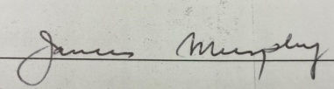 Date: 14/12/2022

Principal: 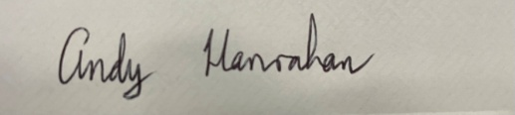 Date: 14/12/2022

