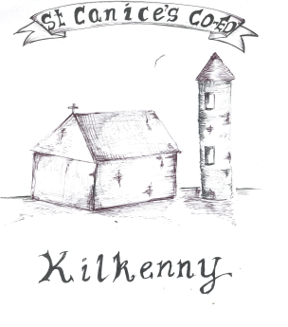
St Canice’s Co-Ed Primary School
Granges Road, Kilkenny.

Retention of a Pupil in the Same Grade Policy

INTRODUCTION

The Primary School Curriculum is designed as an eight year course including a two year infant cycle followed by six years in standards from 1st to 6th class with children progressing to the next grade at the end of each school year. The Primary Curriculum is flexible and child-centred and can be adapted to meet children’s needs.

Circular 32/2003 refers to the retention of pupils in the same class. The Department of Education does not encourage this generally. Under the Department’s policy, children should only be allowed to repeat a year for educational reasons and in exceptional circumstances.
For example:
- a child has not achieved sufficient levels of literacy or numeracy,
- a child has missed a significant level of schooling,
- a child had emotional/behavioural issues that impeded their learning during the course of the year.

AGE

Under the Department’s policy, a school should always endeavour to place a child in an age appropriate setting i.e. with peers of a similar age and stage of development.
St. Canice’s Co-Ed. N.S. will not give consideration to an application to repeat a class, whereby in repeating, a child will reach the age of 13 years on or before the 31st January in sixth class, their final year in the school.
No pupil will repeat a grade more than once in a primary school.

MAKING AN APPLICATION
In order for a child to be retained in the same grade, the parents of the child must submit such a request in writing. Supporting documentation must be submitted with the request.

In accordance with the Department of Education policy, children will only be allowed to repeat a year for educational reasons and in exceptional circumstances. Any decision to acquiesce to a request to repeat a grade will be based on the developmental/learning needs of the child only. In such exceptional circumstances a Principal teacher, following consultation with the Special Education Coordinator, the Special Education Teachers, the class teacher and parent(s), may conclude that a pupil would benefit educationally by repeating a grade level.

RECORD KEEPING
A record outlining the educational basis for the decision to retain a child will be kept for any pupil so retained. In addition, an IPLP will be drawn up indicating what interventions will be put in place for the child to maximise their learning experience and what the expected benefit will be. These records will be retained within the school and will be brought to the Inspector’s attention by the Principal when s/he visits the school.

RATIFICATION, REVIEW AND COMMUNICATION
This policy was ratified by the Chairperson of the Board of Management on 31st January 2023 and subsequently communicated to parents and staff via the school website.

This policy will be reviewed in January 2024 and amended as necessary by means of a whole school collaborative process. It will be reviewed before that date if warranted.

Signed: ______________________________ Date: ______________
Chairperson of the Board of Management

Signed: ______________________________ Date: ______________
Principal

